

**UNIVERSITI TUN HUSSEIN ONN MALAYSIA**

**TEST 1**

**SEMESTER I**

**SESSION 2022/2023**

COURSE NAME : WEB DEVELOPMENT

COURSE CODE : DAT 21303

NAME : QAIREL QAYYUM BIN MUHAMAD RIDHUAN

MATRIC NO : AA212363

SECTION : 6

INSTRUCTION : CONVERT YOUR ANSWERS INTO PDF

FORMAT AND SUBMIT VIA FORM GIVEN.

# **Q1**

Q1 a

--

-- Database: `medsDatabase`

--

CREATE DATABASE medsDatabase1;

-- --------------------------------------------------------

--

-- Table structure for table `companyUsers`

--

CREATE TABLE `companyUsers` (

`userId` int(11) NOT NULL,

`fullName` varchar(50) NOT NULL,

`position` varchar(50) NOT NULL,

`department` varchar(15) NOT NULL,

`userName` varchar(25) NOT NULL,

`password` varchar(15) NOT NULL

) ENGINE=InnoDB DEFAULT CHARSET=utf8mb4 COLLATE=utf8mb4_general_ci;

--

-- Dumping data for table `attendance`

--

INSERT INTO `companyUsers` (`userId`, `fullName`, `position`, `department`, `userName`, `password`) VALUES

(1, 'Alie Baker', 'manager', 'sales', 'aliebaker', '******'),

(2, 'Ahmad reza', 'manager', 'IT', 'ahmadRezza', '******'),

(3, 'Sarah Hannes', 'manager', 'administration', 'sarahhannes', '******'),

(4, 'Clara McClaren', 'programmer', 'IT', 'claraMcclaren', '******'),

-- --------------------------------------------------------

--

-- Table structure for table `customers`

--

CREATE TABLE `customers` (

`custId` int(11) NOT NULL,

`custName` varchar(50) NOT NULL,

`custAdd` varchar(20) NOT NULL,

`custContact` varchar(15) NOT NULL,

`userName` varchar(25) NOT NULL,

`password` varchar(15) NOT NULL

) ENGINE=InnoDB DEFAULT CHARSET=utf8mb4 COLLATE=utf8mb4_general_ci;

--

-- Table structure for table `products`

--

CREATE TABLE `products` (

`productId` int(11) NOT NULL,

`productName` varchar(50) NOT NULL,

`productCode` varchar(15) NOT NULL,

`price` varchar(10) NOT NULL,

) ENGINE=InnoDB DEFAULT CHARSET=utf8mb4 COLLATE=utf8mb4_general_ci;

--

-- Table structure for table `orders`

--

CREATE TABLE `orders` (

`orderId` int(11) NOT NULL,

`orderDate` varchar(10) NOT NULL,

`prodId` int(10) NOT NULL,

`qty` int(10) NOT NULL,

`shipperId` int(11) NOT NULL,

) ENGINE=InnoDB DEFAULT CHARSET=utf8mb4 COLLATE=utf8mb4_general_ci;

--

-- Table structure for table `suppliers`

--

CREATE TABLE `suppliers` (

`supplierId` int(11) NOT NULL,

`companyName` varchar(50) NOT NULL,

`contactPeson` varchar(15) NOT NULL,

`city` varchar(15) NOT NULL,

`country` varchar(15) NOT NULL,

) ENGINE=InnoDB DEFAULT CHARSET=utf8mb4 COLLATE=utf8mb4_general_ci;

--

-- Table structure for table `shippers`

--

CREATE TABLE `shippers` (

`shipperId` int(11) NOT NULL,

`companyName` varchar(50) NOT NULL,

`contactPeson` varchar(15) NOT NULL,

`city` varchar(15) NOT NULL,

`country` varchar(15) NOT NULL,

`contactNumber` varchar(15) NOT NULL,

) ENGINE=InnoDB DEFAULT CHARSET=utf8mb4 COLLATE=utf8mb4_general_ci;

q1 b

<!--LOGIN-->

<!doctype html>

<html>

<head>

<meta charset="utf-8">

<title> Login </title>

</head>

<body>

<!--FORM LOGIN-->

<br>

<table border="3px" bordercolor = "black">

<tr>

<td >

<table>

<form action='L7conn.php' method="POST">

<tr> <th colspan="2"> Login <br><br> </th> </tr>

<tr>

<td>Username:</td>

</tr>

<tr>

<td><input type ="text" name = "username" size="42" placeholder"Username"> </td>

</tr>

<tr>

<td>Password : </td>

</tr>

<tr>

<td><input type = "password" name = "password" size="42" placeholder"Password"></td>

</tr>

<tr>

<td><br>

<input type = "submit" name = "save" value = "Login">

</td>

</tr>

</form>

</table>

</td>

</table>

</body>

</html>

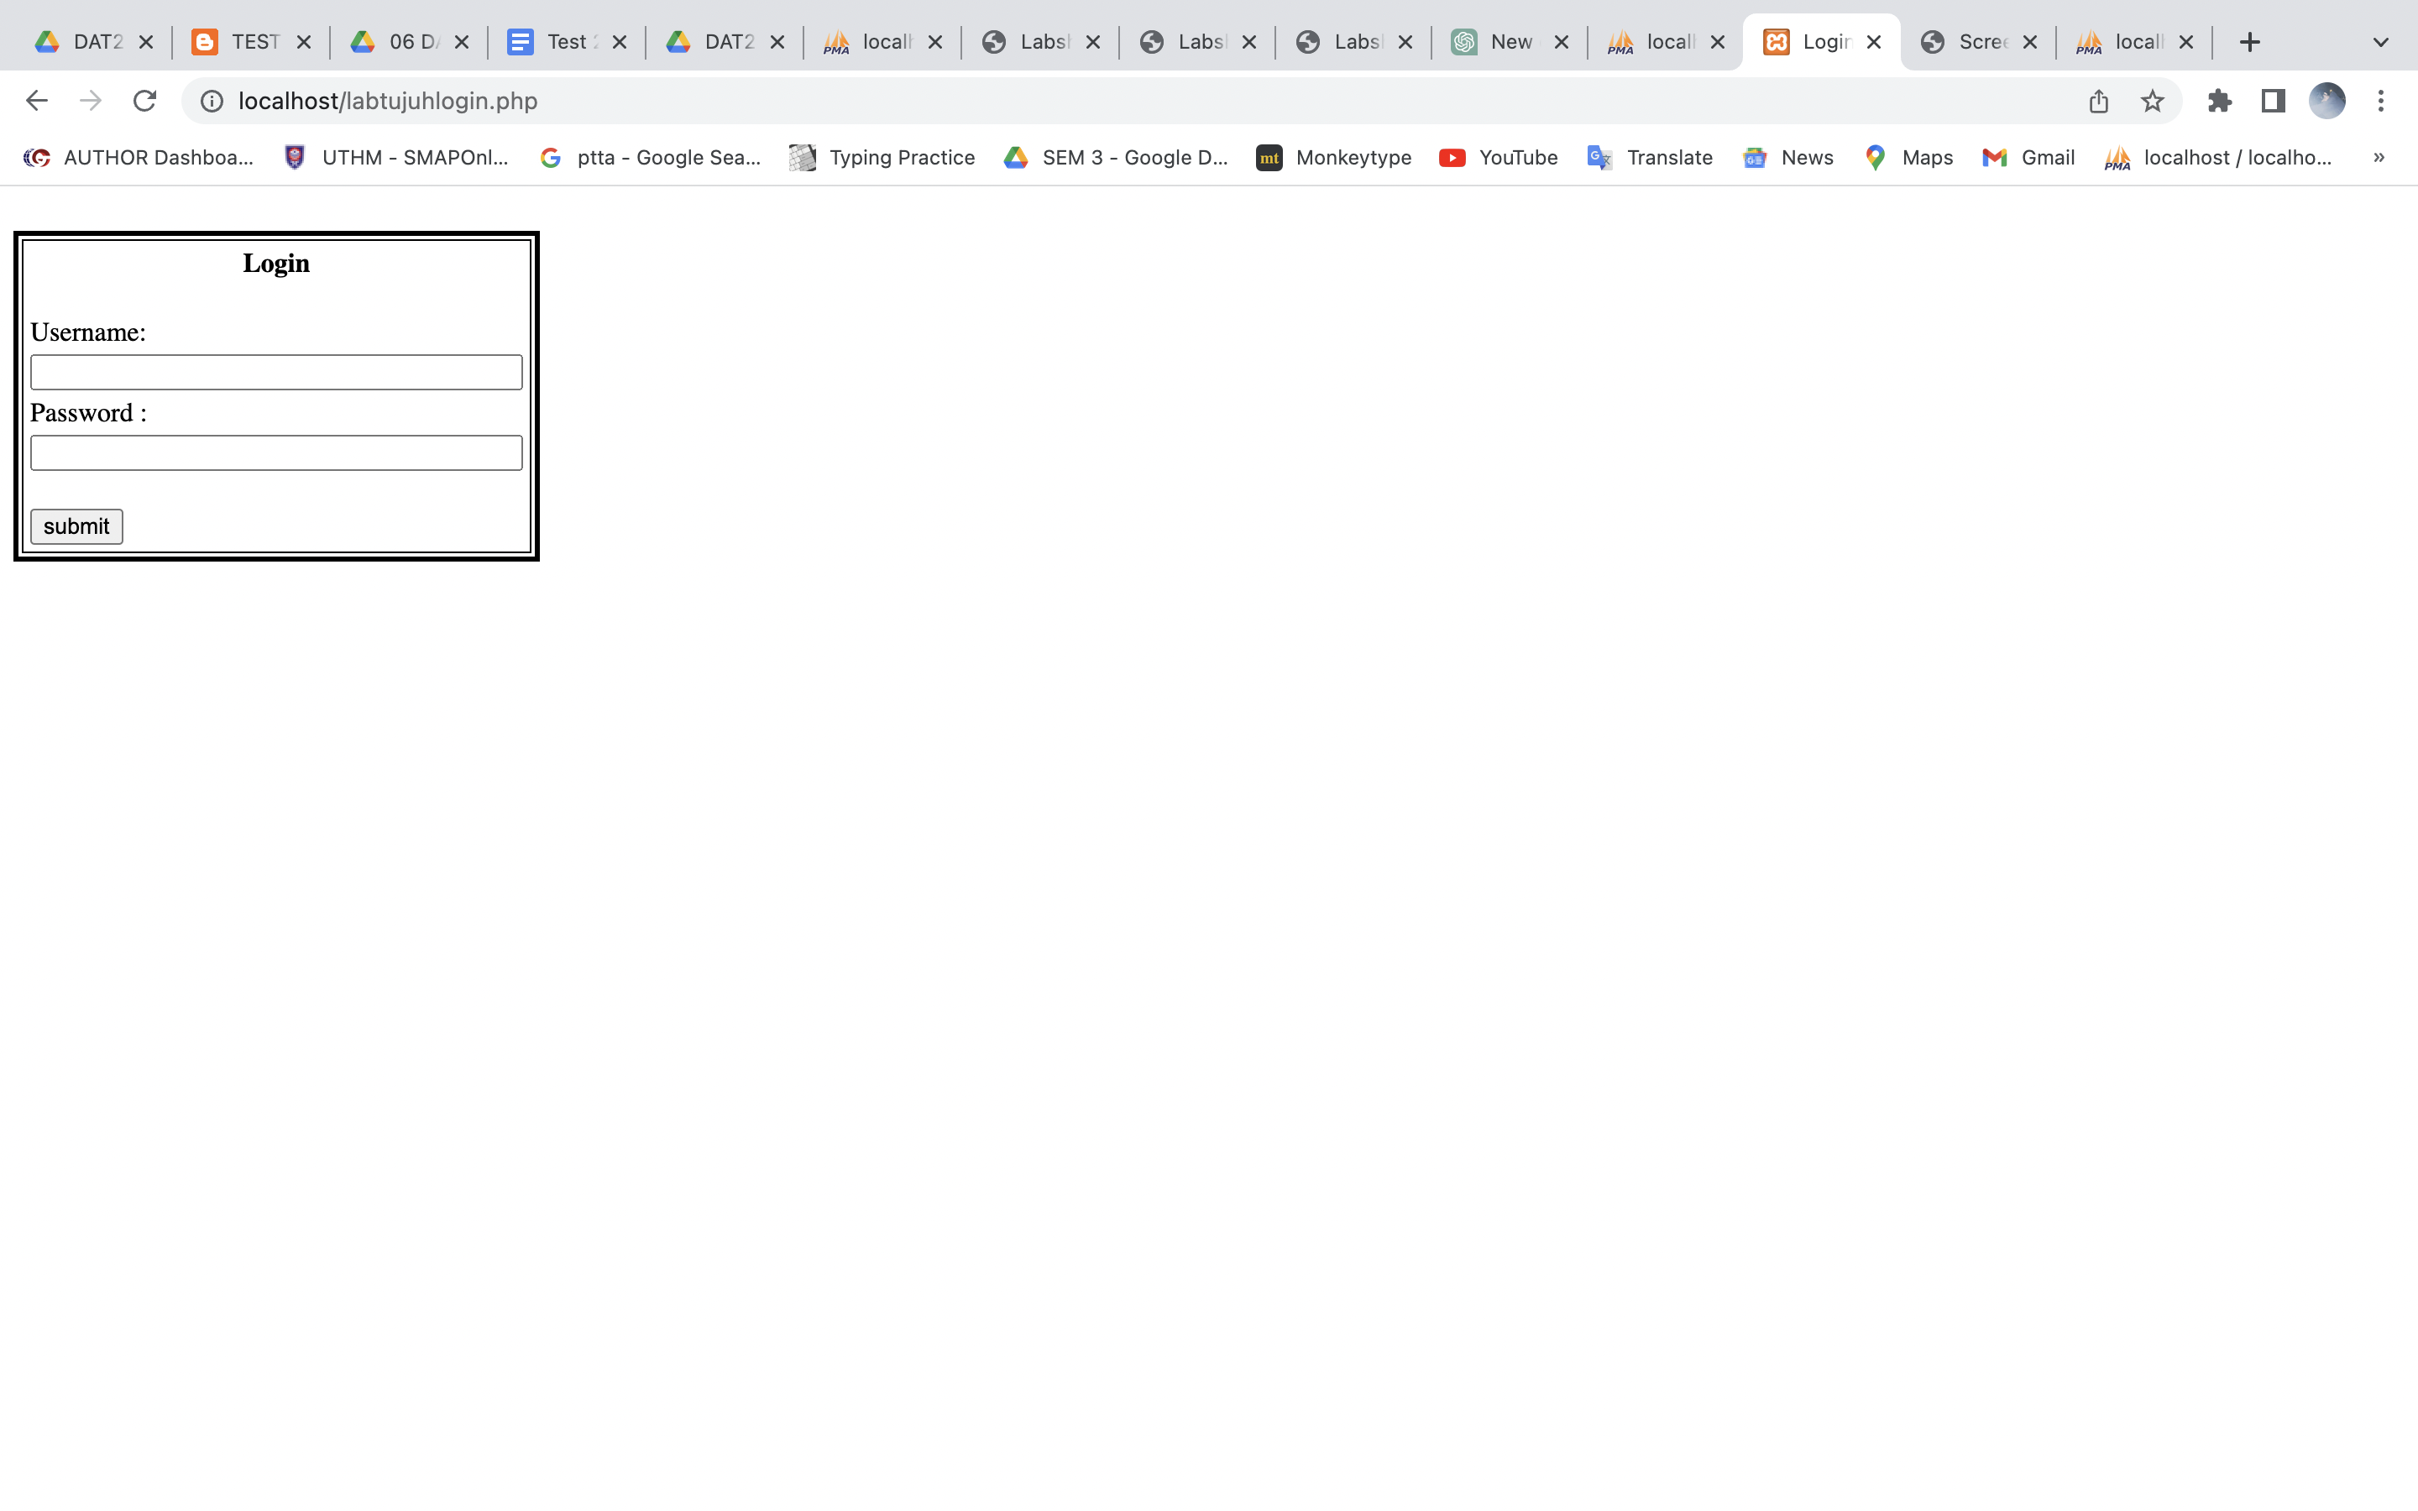

**Q1 c**

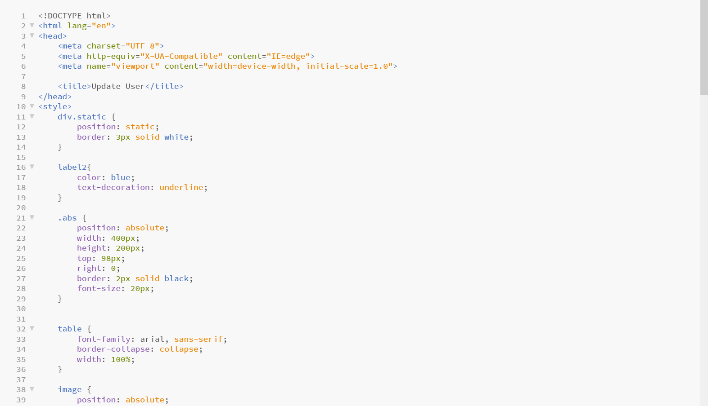

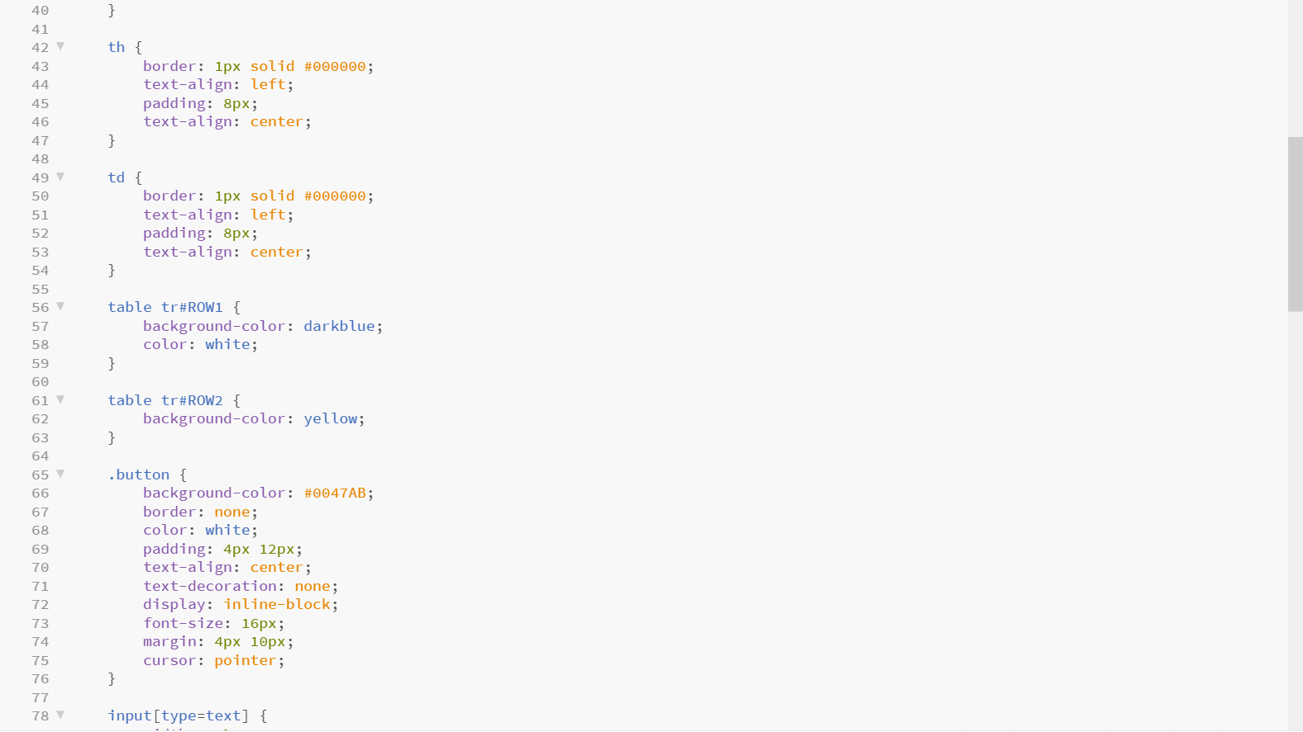

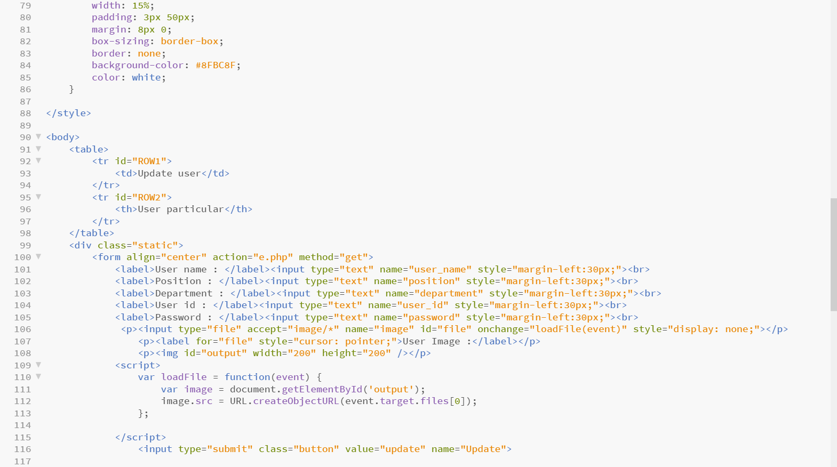

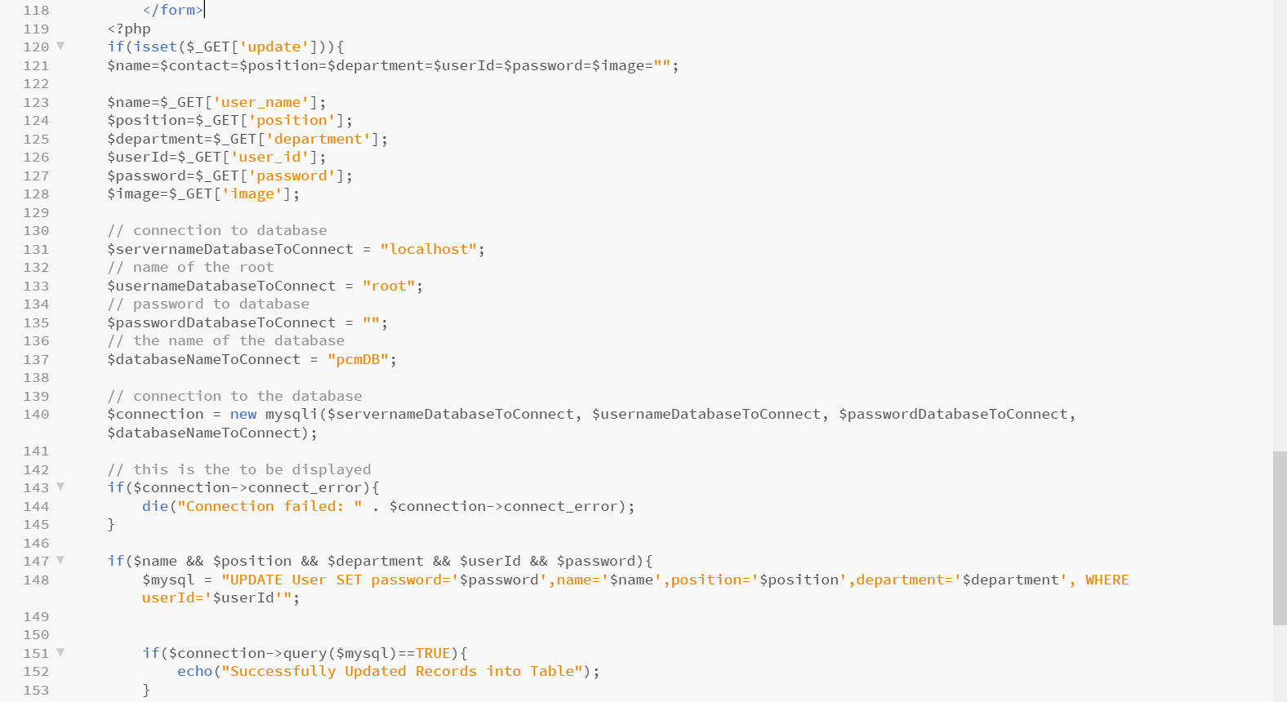

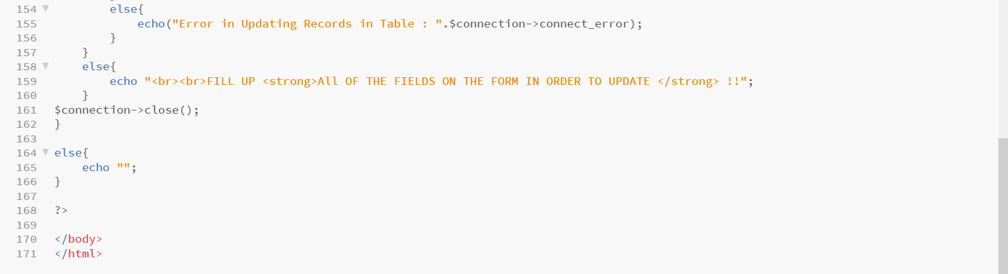

**Q1 e**

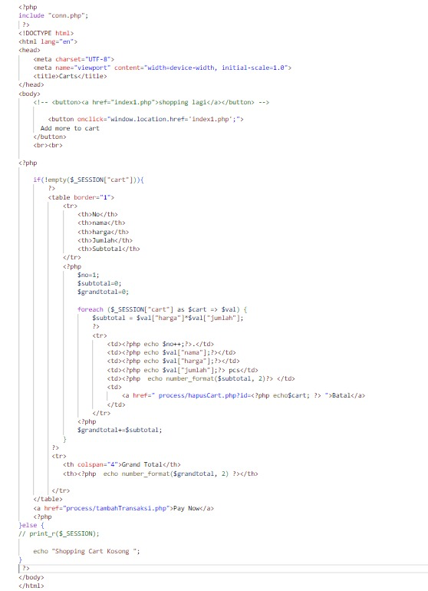

**Q1 f**

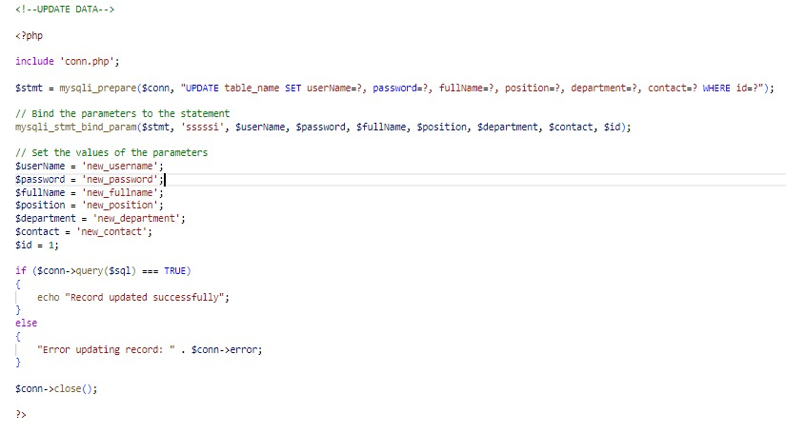



**Q1 G**

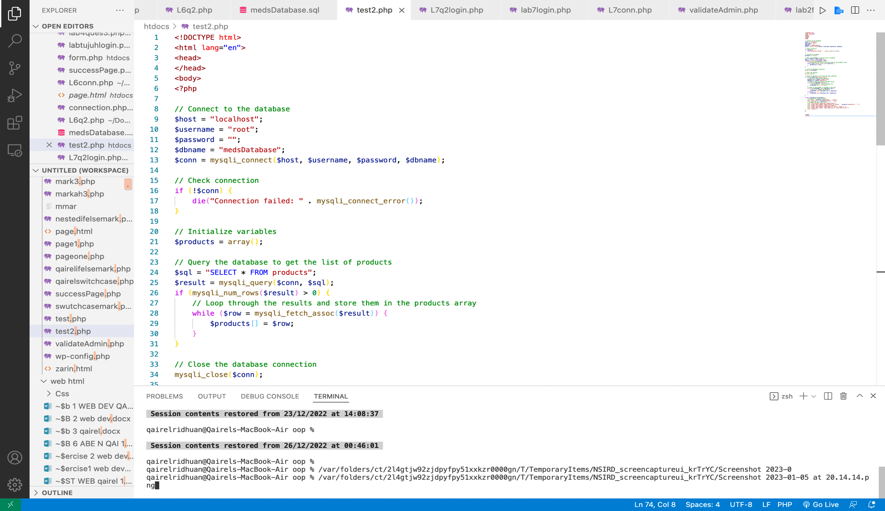

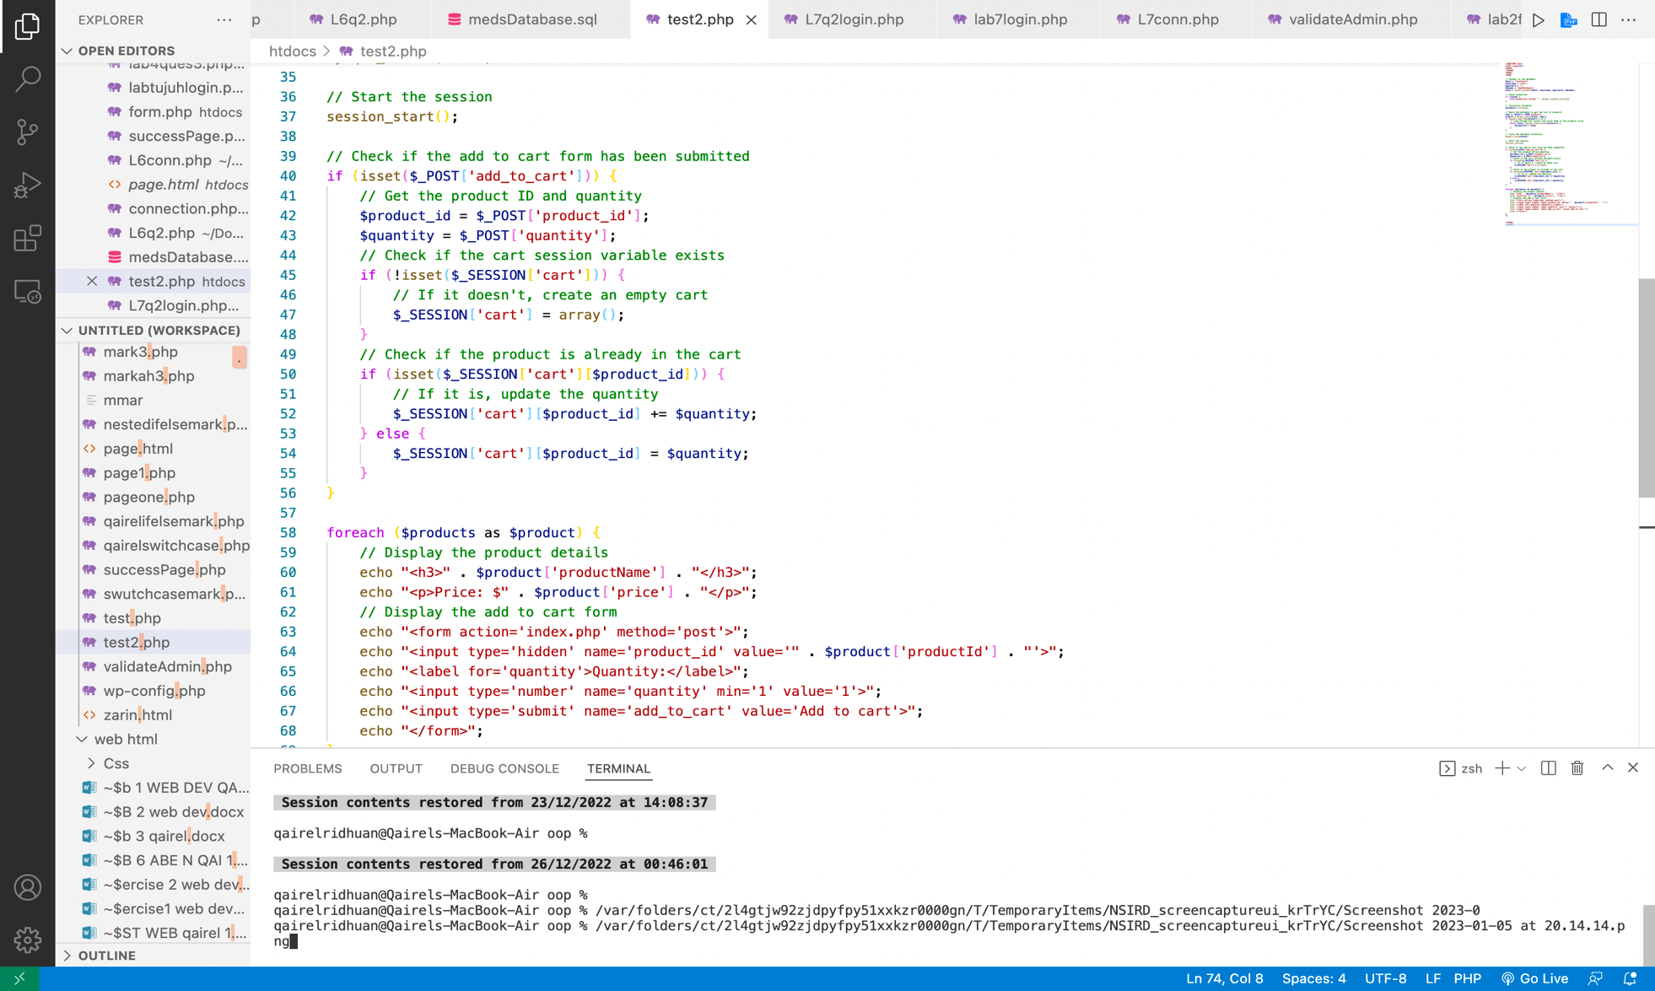

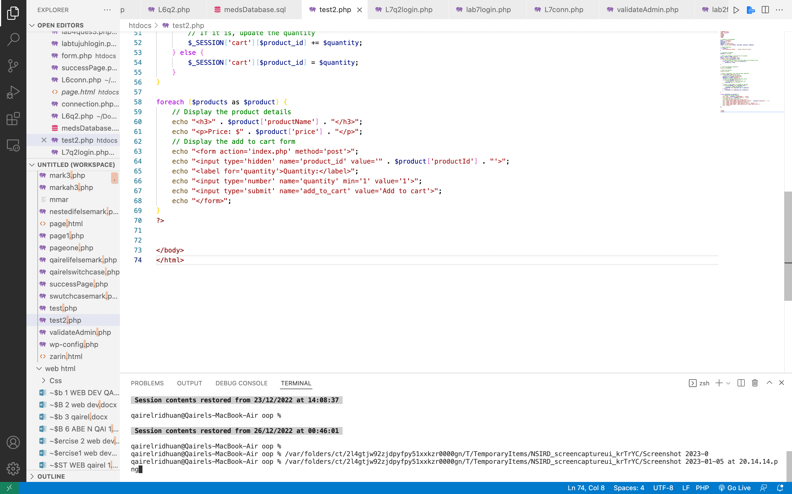

**Q1 H**

<!DOCTYPE html>

<html lang="en">

<head>

</head>

<body>

<?php

// Connect to the database

$host = "localhost";

$username = "root";

$password = "";

$dbname = "medsDatabase";

$conn = mysqli_connect($host, $username, $password, $dbname);

// Check connection

if (!$conn) {

die("Connection failed: " . mysqli_connect_error());

}

// Initialize variables

$products = array();

// Query the database to get the list of products

$sql = "SELECT * FROM products";

$result = mysqli_query($conn, $sql);

if (mysqli_num_rows($result) > 0) {

// Loop through the results and store them in the products array

while ($row = mysqli_fetch_assoc($result)) {

$products[] = $row;

}

}

// Close the database connection

mysqli_close($conn);

// Start the session

session_start();

// Check if the add to cart form has been submitted

if (isset($_POST['add_to_cart'])) {

// Get the product ID and quantity

$product_id = $_POST['product_id'];

$quantity = $_POST['quantity'];

// Check if the cart session variable exists

if (!isset($_SESSION['cart'])) {

// If it doesn't, create an empty cart

$_SESSION['cart'] = array();

}

// Check if the product is already in the cart

if (isset($_SESSION['cart'][$product_id])) {

// If it is, update the quantity

$_SESSION['cart'][$product_id] += $quantity;

} else {

$_SESSION['cart'][$product_id] = $quantity;

}

}

foreach ($products as $product) {

// Display the product details

echo "<h3>" . $product['productName'] . "</h3>";

echo "<p>Price: $" . $product['price'] . "</p>";

// Display the add to cart form

echo "<form action='index.php' method='post'>";

echo "<input type='hidden' name='product_id' value='" . $product['productId'] . "'>";

echo "<label for='quantity'>Quantity:</label>";

echo "<input type='number' name='quantity' min='1' value='1'>";

echo "<input type='submit' name='add_to_cart' value='Add to cart'>";

echo "</form>";

}

?>

</body>

</html>

**Q1 I**

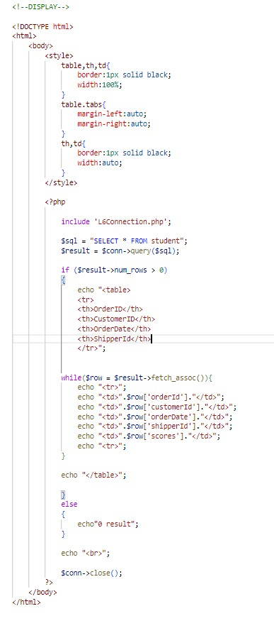

**Q1 J**

